BDSC 340 – Operations Management Fall 2018

Assignment 8
Instructions:
a) Show all the steps followed to arrive at the answer (page 683- 694)

1. Solve the Problem A.9

- Expected Values
Batch- 0.1*(-200000)+0.4*1000000+0.3*1200000+0.2*1300000
=1000000
Custom-0.1*100000+0.4*300000+0.3*700000+0.2*800000
=500000
Group Tech-0.1*(-1000000)+0.4*(-500000)+0.3*500000+0.2*2000000=250000
Based on the expected values the best choice will be Batch Process.
- Expected value forecasted
=0.1*100000+0.4*1000000+0.3*1200000+0.2*2000000=1170000
Faye Zhu will be willing to pay for a forecast that would accurately determine the level of demand in the future
= 1170000 – 1000000
=170000

2. A.11
a. 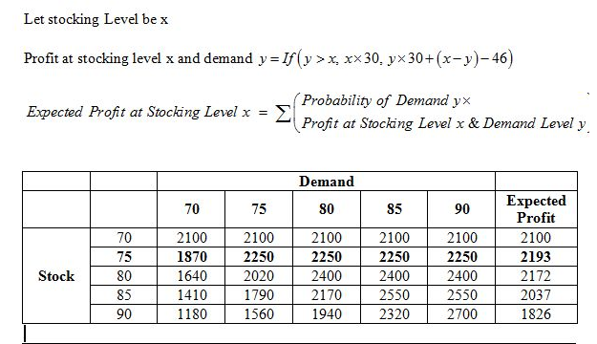
The expected profit is a maximum of 75 units.
b. in order to meet demand, Bookstore should have at least 75 units.

3. A.13
Veenaganswered this
a) EMV decision:
Large inventory = (20,000 * 0.30) + (10,000 * 0.5) + (-1000 * 0.2)
= 6000 + 5000 - 200
= $10,800
Average inventory = (15,000 * 0.3) + (15,000 *0.5) + (4000* 0.2)
= 4500 + 7500 + 800
= $12,800
Small inventory = (9000 * 0.3) + (6000 * 0.5) + (5000 * 0.2)
= 2700 + 3000 + 1000
= $6700
The best alternative for Deborah with the greatest EMV is Average Inventory with EMV value for $12,800
b) EVPI :
EVPI with perfect information (EVwPI) = 0.3(20,000) + 0.50 (15,000) + 0.20 (5000)
= 6000 + 7500 + 1000
= $14,500
EVPI without perfect information (EVwoPI) = 0.3(15,000) + 0.5(15,000) + 0.2(4000)
= 4500 + 7500 + 800
= $12,800
EVPI = (EVwPI – EvwoPI)
= 14,500 - 12,800
= 1,700

